1. Cpu goes to 100% and we found random zombie process with “D” state with APACHE.

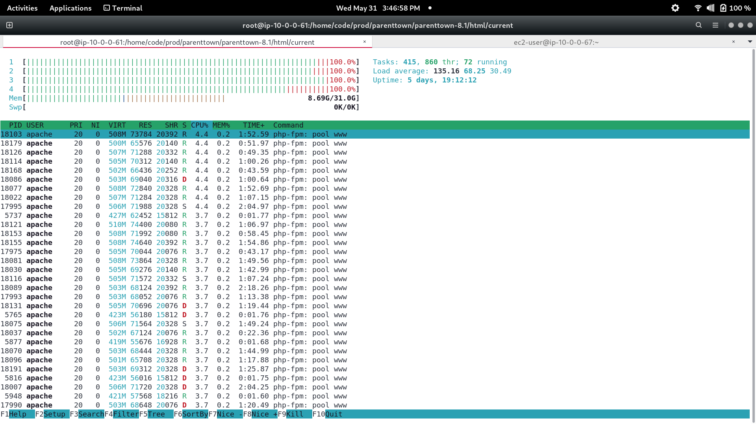

1. ELB [VPC-ELB-PT](https://ap-southeast-1.console.aws.amazon.com/ec2/home?region=ap-southeast-1#LoadBalancers:search=VPC-ELB-PT) monitoring.There are too many ELB 5xxs errors here compared to HTTP 5xxs

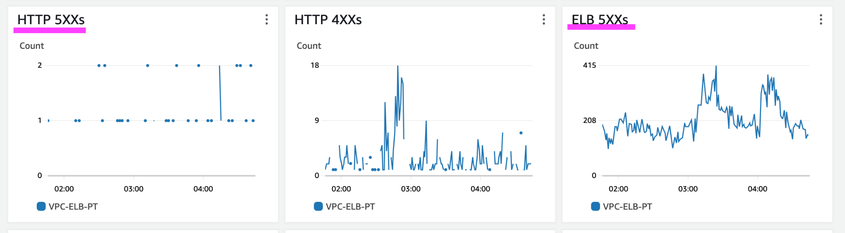

# 

# Access log nginx of EC2 server.

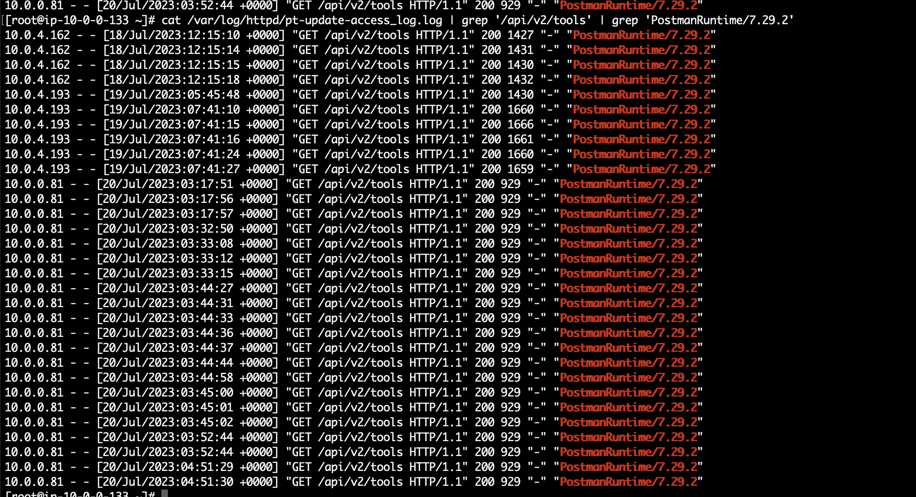

Tried to call the api from postman with User agent: PostmanRuntime/7.29.2 still getting http error 504 but access log of apache does not appear this error at all. This means the request did not reach apache bcoz only when we attach the Laraval server the server goes to 100% cpu.

1. We tried with nginx too but the Cpu goes to 100% and found random zombie process with “D” state with NGINX configuration.

